ONLINE RESUME BUILDER
@CREATIVITY THINK (9483175986/7019689991)

ABSTRACT:
The Online Resume Builder is a web-based application designed to help users create professional resumes with ease. The platform enables users to fill in structured sections such as personal information, education, skills, and work experience, and then preview and customize resume templates. Users can download their resumes in PDF format and manage multiple versions via a dashboard. Administrators oversee template management, moderate published resumes, and access analytics to understand usage patterns. Built using Django and Django Rest Framework for backend operations and React with html2pdf for frontend functionality, the system offers a streamlined, efficient, and user-friendly solution for resume creation..

INTRODUCTION OF THE PROJECT:
A well-designed resume plays a crucial role in job applications, yet many applicants struggle with formatting and layout. The Online Resume Builder helps eliminate these challenges by providing structured forms and customizable templates that guide users in creating visually appealing and professional resumes. The system provides PDF export options, template switching abilities, dashboard editing, and analytics insights for administrators. With Django managing backend logic and React for user interaction, the platform offers secure authentication, intuitive design capabilities, and scalable features suitable for students, professionals, and career guidance institutions..

PROJECT OBJECTIVES:

• To provide users with structured templates for creating professional resumes
• To allow customization and PDF export of resumes
• To enable dashboard-based management of multiple resume versions
• To provide admins the ability to manage templates and moderate resumes
• To ensure secure handling of user information and resume data
• To implement analytics dashboards for administrators
• To support fast, accessible, and user-friendly resume building on the web

PROBLEM OF THE STATEMENT:
Job seekers often face challenges in creating well-formatted resumes due to lack of design knowledge, inconsistent templates, or time constraints. Traditional tools may require advanced editing skills or paid software, making resume creation difficult for many users. Career centers and professionals also need a centralized platform to manage templates and monitor usage. The Online Resume Builder addresses these issues by offering structured forms, customizable templates, PDF downloads, and admin controls through an intuitive web interface..

MOTIVATION OF THE PROJECT:
• Provide an accessible tool for creating professional resumes
• Save time and effort for users by offering pre-built templates
• Support institutions in guiding applicants with consistent formats
• Reduce dependency on paid or complex design software
• Enable easy editing, updating, and PDF exporting of resume data

BLOCK DAIGRAM OF PROJECT:

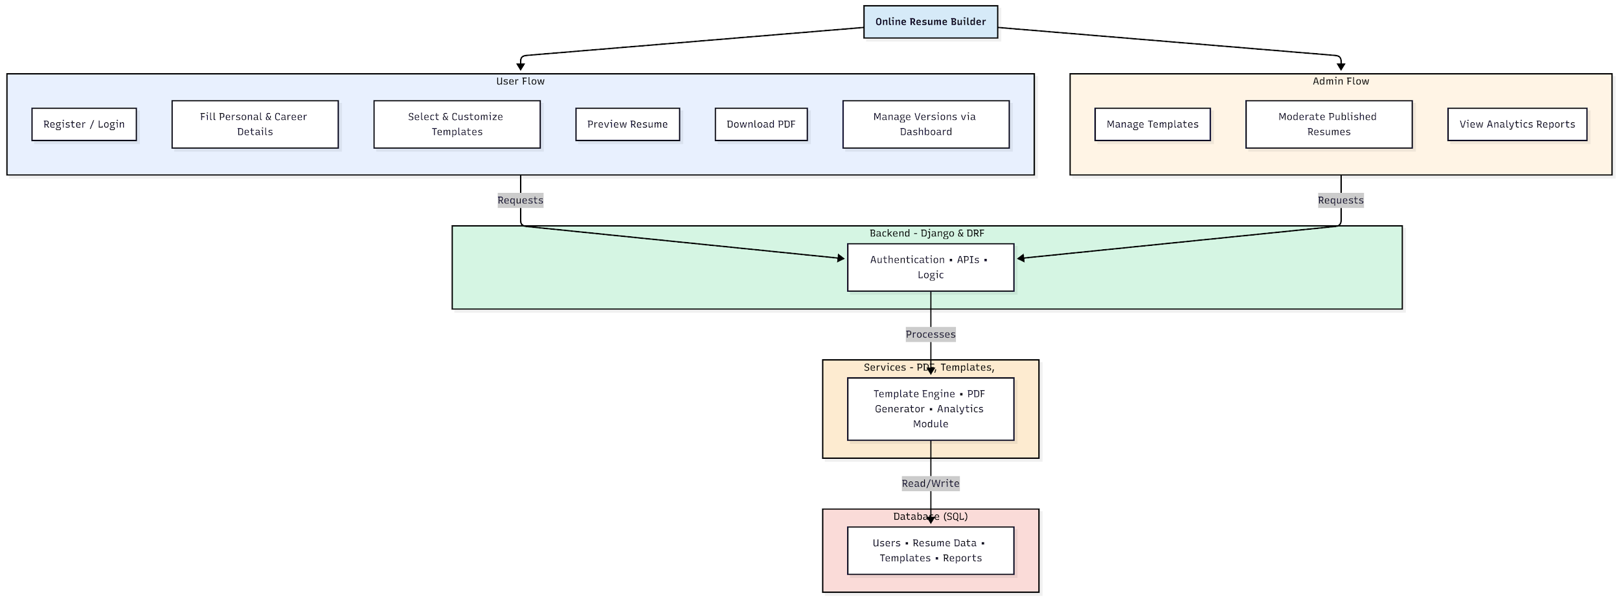

WORKING OF THE PROJECT:
Users begin by registering or logging into the Online Resume Builder, after which they fill in structured personal, educational, and professional details. They then choose from available templates and customize layout and formatting. Users can preview their resume in real time and download it as a PDF using integrated conversion tools. The dashboard allows management of multiple resume versions. Administrators control template availability, moderate user-published resumes, and monitor analytics such as usage frequency and template popularity. The backend handles authentication, API processing, and data management, while frontend services manage template rendering and PDF generation..

SOFTWARE REQUIREMENT:
- Backend:
  - Python 3.x
  - Django
  - Django REST Framework
  - SQLite/PostgreSQL
- Frontend:
  - Node.js and npm
  - React.js
  - Axios
- Development Tools:
  - Visual Studio Code
  - Postman (for testing APIs)
  - Git/GitHub (for version control)
- Server/Deployment (Optional):
  - Gunicorn, Nginx, or Heroku/AWS for hosting

ADVANTAGES OF THE PROJECT:

• Easy creation of professional resumes
• PDF export with consistent formatting
• Multiple templates and customization options
• Secure user authentication and data storage
• Admin moderation and template control
• Dashboard for editing and managing resume versions
• Analytics for understanding template popularity
• No need for external design or editing software

APPLICATIONS OF THE PROJECT:
• Job applicants preparing resumes
• Career guidance centers
• Universities and placement cells
• HR departments assisting new applicants
• Professionals updating resumes regularly
• Online job portals integrating resume creation
• Training institutes teaching resume writing
• Freelancers providing resume services

REFERENCES:

- Django REST Framework Documentation — Django Software Foundation. Django Documentation. Available: https://docs.djangoproject.com/
- Django REST Framework. DRF Documentation. Available: https://www.django-rest-framework.org/
- React. React Official Documentation. Available: https://reactjs.org/docs/getting-started.html
- Redux. Redux Documentation. Available: https://redux.js.org/introduction/getting-started
- PostgreSQL Global Development Group. PostgreSQL Documentation. Available: https://www.postgresql.org/docs/
- MySQL. MySQL Reference Manual. Available: https://dev.mysql.com/doc/
- Git. Git Documentation. Available: https://git-scm.com/doc
- Node.js. Node.js Documentation. Available: https://nodejs.org/en/docs/
- Axios. Axios Documentation. Available: https://axios-http.com/docs/intro
- Socket.io Documentation – https://socket.io/docs/

